C++ Library Management System themed around cartoon characters.
User Features
- Register new users (auto ID generation)
- Rent books (Printed Books & E-Books supported)
- Return books
- Pay outstanding balance / fines
- View borrowed books with due dates and overdue fines ($0.50/day)
Admin Features (Password: `chad7`)
- Show All Data
- View All Users
- View Books Available
- Display All Rented Books
- Search Books (Title / Author / Genre)
- Exit Admin Menu
Technical Features
- JSON persistent storage (`data.json` + auto backup)
- Polymorphism (`Book` → `PrintedBook`, `EBook`)
- Input validation & error handling
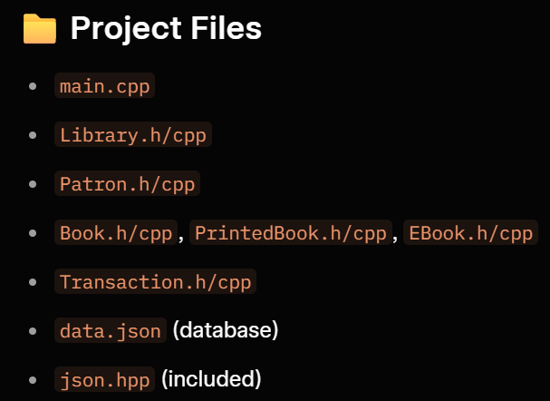
- Cartoon-themed goodbye messages

How to compile.
g++ -std=c++17 main.cpp Library.cpp Patron.cpp Book.cpp PrintedBook.cpp EBook.cpp Transaction.cpp -o ToonLibrary

To run type: Main.exe

